Sales Performance Analysis

Mike Goodman, the head of Product Management of a retail products company, is responsible for determining which products his company should continue to offer for sale and which products should be discontinued from the company’s product catalog. Mike wants to build a dashboard that will present monthly sales performance by product segment and product category to help him identify the segments and categories that have met or exceeded their sales targets, as well as those that have not met their sales targets.

**Screenshot of the Dashboard:**

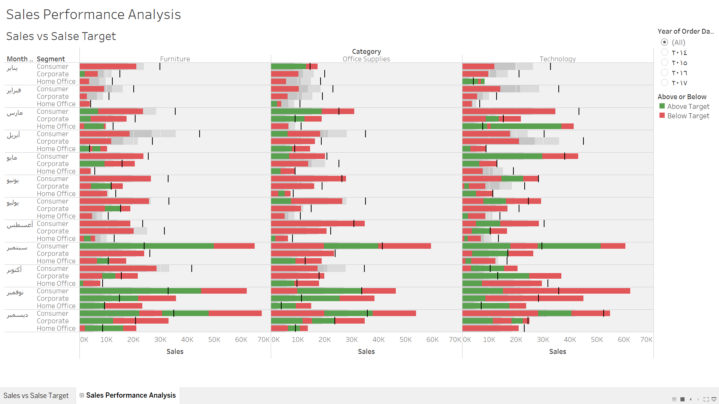

Link of my project work in Tableau Public:

<https://public.tableau.com/app/profile/shahad.tariq/viz/TableauProject2-SalesPerformanceAnalysis_16227807880530/SalesPerformanceAnalysis>